# Mixing normal images and adversarial images when training CNNs

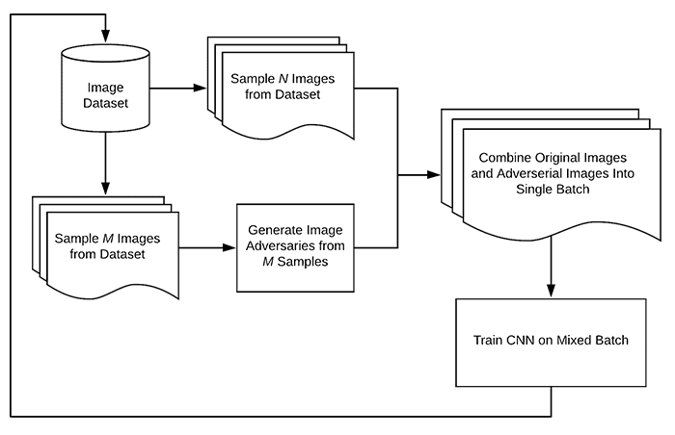

|  |  |  |
| --- | --- | --- |
| **Case** | **Loss** | **acc** |
| normal testing images on the model (normal test) | 0.4390 | 86% |
| mixing normal and adversarial testing image (80-20) on the model (normal test) | 18.0093 | 69% |
| normal testing images on the model1 (normal test)  (model1 has the same architecture as model) | 0.4861 | 85% |
| mixing normal and adversarial testing image (80-20) on the model1 (test 80-20) | 0.3944 | 88% |



